
Cloud Optimization Project Plan
Managed Cloud & Infrastructure Services
20 October 2023 | Document Version V3

Version | Date | Comments
1 | 14 October 2023 | First version
2 | 16 October 2023 | Second version
3 | 20 October 2023 | Final version

NTT contact details
We welcome any enquiries regarding this document, its content, structure, or scope. Please contact:

NTT Taiwan Solutions Limited
Eric Chan – Senior Service Architect
Mobile:0910114111
Tel:02-21713365
eMail:e-chan@global.ntt

Confidentiality
This document contains NTT Limited ('NTT') confidential information. You may not disclose the confidential information to any third party without NTT’s written consent.



Table of Contents
NTT contact details 2
Confidentiality 2
1. Managed Cloud and Infrastructure Services (MCIS) 4
1.1. MCIS Portfolio Overview 4
2. Introduction 5
2.1. Technology Standards 6
2.2. Billing 6
3. Security and Compliance 7
3.1. Data Types and Protection 7
3.2. Information Security Incident Management 7
3.3. Company Standards and Certifications 7
4. Service Report 8
4.1. 工作項目 8
4.2. Task Report 9

Managed Cloud and Infrastructure Services (MCIS)
Systems running on hybrid cloud infrastructure (public cloud, private cloud, data center and co-location) must be monitored, measured, and reported on by staff who need to focus on delivering service to the business in addition to supporting technology.
NTT has developed its approach to managing hybrid IT with these factors in mind. Our managed services are focused on driving operational standards to manage the daily operations of Client infrastructures through:
- Building on a core of industry best-practice processes (ITIL, ISO27001)
- Driving automation to enable higher levels of availability and enable enhanced and consistent user experience
- Ensuring continual service improvement, and empowering Clients with the information to make business decisions about their IT environment through data collection, analysis, and dissemination
- Providing an integrated service delivery model with centralized service delivery combined with regional and country resources to provide support when and where needed
- Combining our cross-competencies in Cloud, DevOps, network, workplace and collaboration, data center and security to provide an integrated and standardized end to end managed service experience across the entire IT estate

MCIS Portfolio Overview
NTT has developed its portfolio of managed services (referred to in this document as the “Service”) to include the following:
- Managed Public Cloud
- Managed Private Cloud
- Managed Data Center & Networking Infrastructure
- Managed Application Infrastructure (OS, DB and Middleware)
- Managed Applications
- Managed Cloud Security & Managed SAP Security
- Managed End User Services
Each of these service offers contain multiple service offer options. Clients work with NTT to define requirements in Scope in the SOW for one or more service offer options so that a managed services solution can be deployed that meets technical and budgetary requirements.

Introduction
NTT has developed a Cloud Transformation Journey to support clients through their transition to our Managed Cloud and Infrastructure Services. Engagements begin by Assessing and Understanding the client's solution requirements to Advise on digital transformation and to Design a high-level architecture plan and transition roadmap. Designs are then further detailed and finalized, and transition plans are executed to onboard the client into the managed environment. Depending on scope, new systems are Deployed and/or existing systems are Migrated to supported managed services platforms. Operate services provide security, support and ongoing maintenance of the client’s systems while Optimize and Advisory services promote continuous improvement, cost efficiency and transformation.
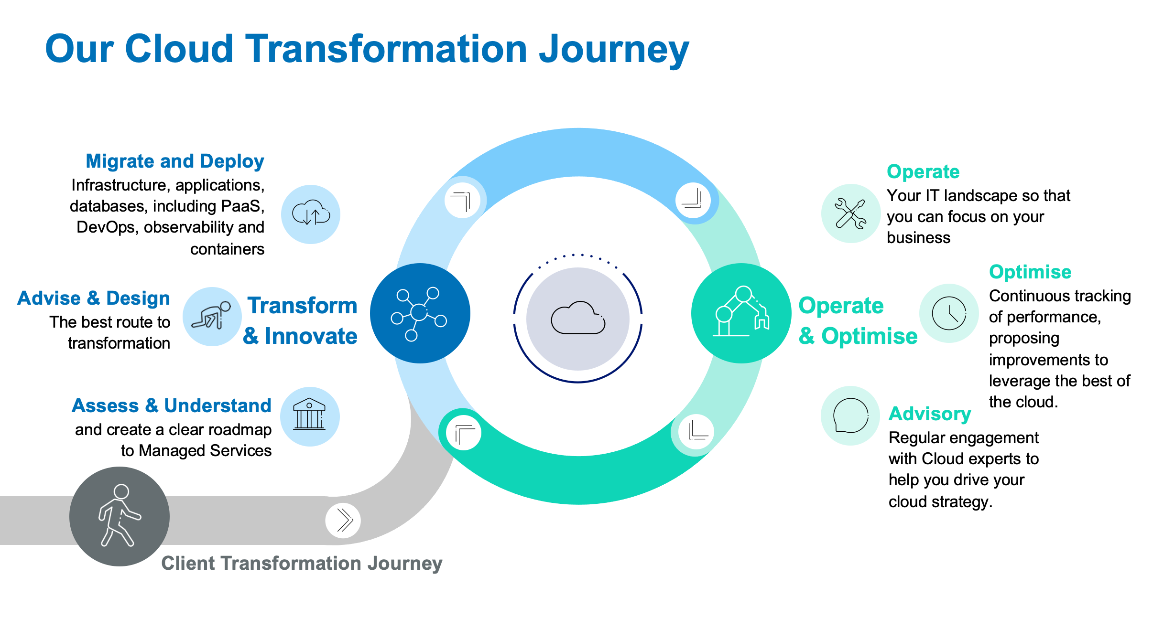
Figure 1 Our Cloud Transformation Strategy
The Cloud Transformation Journey is only provided for selected services that are In Scope for managed services in the SOW and cannot be provided on a standalone basis.

NTT MCIS can support systems running on the following platforms:
- Public Cloud (AWS, Azure, GCP)
- Private Cloud (VMware, Nutanix, Microsoft Azure Stack family)
- NTT Private Cloud
- Multi-Cloud (Private, Public and Hybrid Cloud)
- Traditional infrastructure on premises or in a co-located data center

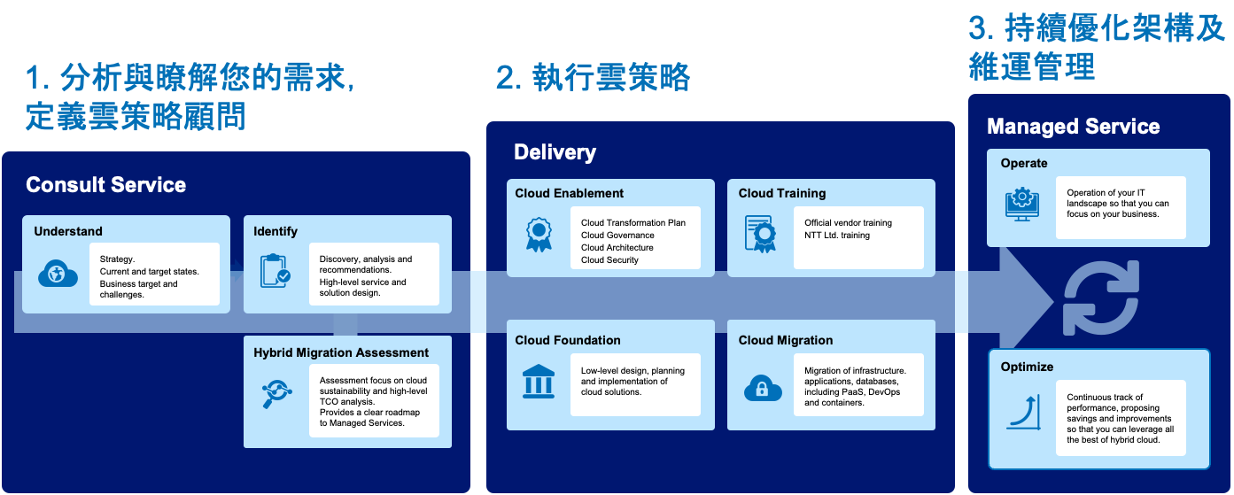

Technology Standards
NTT has developed standard offers for our entire service portfolio which provide specific monitoring configurations, Client requests and setup tasks for supported technologies. These technology specific standard offers are described in the MCIS Services Guide.

Billing
The client contracts for one or more service offers for each IT asset that is to be managed by NTT MCIS. Each IT component under management is referred to as a Configuration Item (“CI”). A configuration item (CI) is any service component that needs to be managed, such as a router, an operating system, or a database.
The client is billed monthly for each managed service contracted for the support of a service component as specified in the SOW.
For public cloud scalable assets, the client is billed only for the management of the base image and its software components (regardless from the number of servers deployed from it).
Public cloud PaaS, Serverless and Container solutions are billed based on the platforms used, use case, and complexity as specified in the SOW.

Security and Compliance

Data Types and Protection
NTT may process, store, or access the following types of data in delivery of the Client Service which shall be subject to the Agreement:
- Hosted data which resides in the managed Client environment
- Service data found in NTT systems (e.g., service tickets, documentation, billing, etc.)
NTT will protect hosted and service data in accordance with the SOW. This data may include but not be limited to subtypes or categories of data such as personal data, confidential information, configuration data, CMBD data, log data, or other controlled data subject to specific industry or government mandates.

Information Security Incident Management
NTT has policies, processes, and procedures for detecting, identifying, notifying appropriate stakeholders of, responding to, and recovering from information security incidents in the event of an information security incident, including personal data breaches. This includes mechanisms for performing a root cause analysis and undertaking corrective actions.

Company Standards and Certifications
NTT delivers comprehensive managed services while adhering to the highest level of industry-relevant and government standards. Information Technology Infrastructure Library (ITIL) and Control Objectives for Information Related Technologies (COBIT) are the foundation of our product and service offerings, resulting in alignment and certifications to the most common standards such as: ISO, CIS, and NIST. NTT operates a continuous improvement program with multiple standards integrated to support many industries
NTT has undertaken to obtain applicable security-related certifications for certain Services or Service components described in this Client Service Description, including ISO 27001. NTT can provide a copy of its associated certificates for the appropriate service division, where applicable, upon Client request.

Service Report

工作項目
1 | Azure VM | 根據虛擬機器實際使用情況，調整規格以符合實際運算需求。
1.1 | 虛擬機規格調整 | - 檢視虛擬機資源使用率報表。  - 確認虛擬機是否需要調整規格。  - 建議是否採用RI年約以降低費用。
2 | 告警配置 | - 目前已經建立三個Log Analytics工作區，但無實際執行作業。  - 刪除無用的工作區。  - 新增須監控之標的物，例如VM。  - 設定監控項目，例如VM CPU使用率。  - 設定告警項目並通知必須要人員。
2.1 | 刪除無用的工作區 | 刪除無用的Log Analytics
2.2 | 配置效能告警 | - 配置告警項目，確認告警項目，定義告警閥值。  - 確認告警通知對象(email)
2.3 | 資訊安全告警 | 設置Microsoft Defender for Cloud
2.4 | 費用警示 | 根據歷史用量資料，在評估優化後每月帳單金額，新增費用異常告警。
3 | 可視化 | 檢視每個雲端資源，確認用途及關連。
3.1 | 清理無用資源 | 列出無關聯之雲端資源，例如公用IP、網路介面、磁碟等清單，經達和確認後進行刪除作業。
4 | Azure Backup | 目前有三個虛擬機器有執行備份作業，並未涵蓋所有虛擬機器以及磁碟資料，應通盤檢視所有需備份的資源並與使用者討論備份原則，資料留存期限，以及是否有法規需要遵循之資料保存。
4.1 | 資料備份 | - 確認所需備份之虛擬機器。  - 確認是否需要異地備份。  - 確認備份保存期限。
4.2 | 備份規則 | - 刪除不必要的備份設定。  - 設定備份失敗告警。
5 | 帳號管理 | 清查訂閱群組及帳號資訊
5.1 | 清除無用帳號 | 目前系統內有部分無用帳號，建議清除。
6 | 資訊安全 | 確認各系統安全配置及網路安全
6.1 | 網段存取 | 確認防火牆規則。
6.2 | 虛擬機器 | 確認虛擬機器安全性，包含defender及更新修補
6.3 | 網路連線規則 | 確認公網存取權限及VPN設定。
7 | 系統警示 | 確認系統警示項目
8 | 整體架構審視 | 全面審視雲端環境
8.1 | 費用分析 | 確認是否有需要調整及建議事項。
8.2 | 網路架構 | 檢視是否有不合理之網路配置及建議。
8.3 | 其他建議 | 其他於系統檢視過程當中發現之其他建議。

Task Report
編號 | 項目 | 執行說明
1 | Azure VM | 根據虛擬機器實際使用情況，調整規格以符合實際運算需求。
1.1 | 虛擬機規格調整 | - 檢視虛擬機資源使用率報表。  - 確認虛擬機是否需要調整規格。  - 建議是否採用RI年約以降低費用。
VM Name | Specification | Disk | Cost (month)
AzureFlexSRV | Standard D4s v3  (4 vCPUs, 16 GB memory) | Premium SSD LRS 128GB Premium SSD LRS 512GB | (VM)10,548 + (Disk)699 + 2,597 = 13,844
AzureFlexSRV | Standard D4ads v5  (4 vcpus, 16 GiB memory) | Standard SSD LRS 128GB  Standard SSD LRS 256GB | (VM)11,018 + (Disk)309 + 619 = 11,946
AzureFlexSRV | 每月節省：1,898
opc | Standard B4ms  (4 vCPUs, 16 GB memory) | Premium SSD LRS 128GB | (VM)5,886 + (Disk)699 = 6,585
opc | Standard D2as v4  (2 vCPUs, 8 GB memory) | Standard SSD LRS 128GB | (VM)5,274 + (Disk)309 = 5,583
opc | 每月節省：1,002
TahoSales | Standard D4s v3  (4 vCPUs, 16 GB memory) | Standard HDD LRS 128GB | (VM)10,548 + (Disk)189 = 10,737
TahoSales | Standard D2as v4  (2 vCPUs, 8 GB memory) | Standard HDD LRS 128GB | (VM)5,274 + (Disk)189 = 5,463
TahoSales | 每月節省：5,274
TahoSQL | Standard D4s v3  (4 vCPUs, 16 GB memory) | Premium SSD LRS 128GB,  2* Premium SSD LRS 1TB | (VM)10,548 + (Disk)699 + 4,795 + 4.795 = 19,662
TahoSQL | Standard D4s v3  (4 vCPUs, 16 GB memory) | Standard SSD LRS 128GB  2* Standard SSD LRS 256GB | (VM)10,548 + (Disk)309 + 619 + 619 = 12,095
TahoSQL | 每月節省：7,567
所有VM經調整每月節省費用：15,741
每年節省費用：188,892

2 | 告警配置 | - 目前已經建立三個Log Analytics工作區，但無實際執行作業。  - 刪除無用的工作區。  - 新增須監控之標的物，例如VM。  - 設定監控項目，例如VM CPU使用率。  - 設定告警項目並通知必須要人員。
2.1 | 刪除無用的工作區 | 刪除無用的Log Analytics
保留OnyxLogAnalyticWorkspace，移除另外三個Log Analytics工作區。
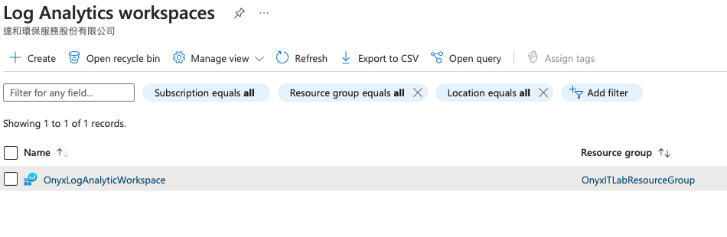

2.2 | 配置效能告警 | - 配置告警項目，確認告警項目，定義告警閥值。  - 確認告警通知對象(email)
1. 針對所有VM配置告警項目：
2. 告警項目：
- 平均CPU使用率超過90
- 最大CPU使用率超過90
- 磁碟IOPS超過95%
- OS磁碟IOPS超過95%
- 可用記憶體小於500MB
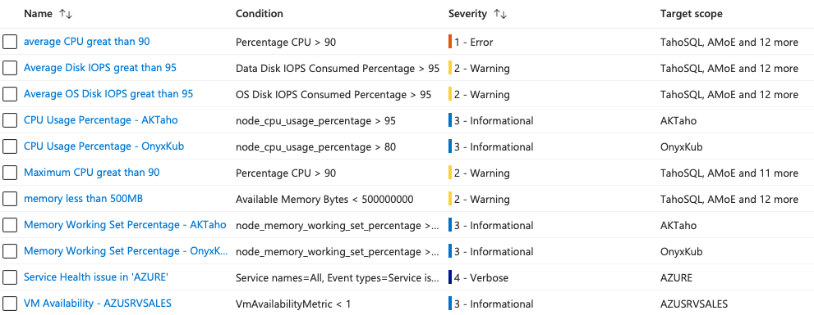

2. 設置email告警： e-chan@global.ntt

2.3 | 資訊安全告警 | 設置Microsoft Defender for Cloud
目前所有VM都已啟用Defender for Cloud
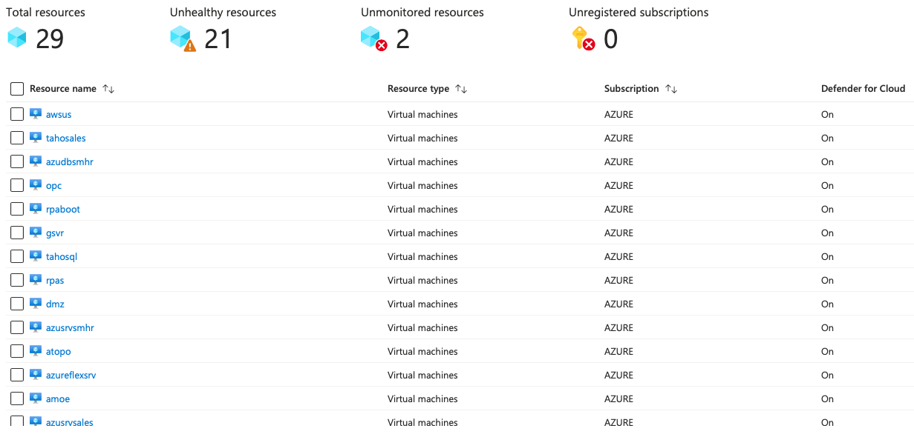
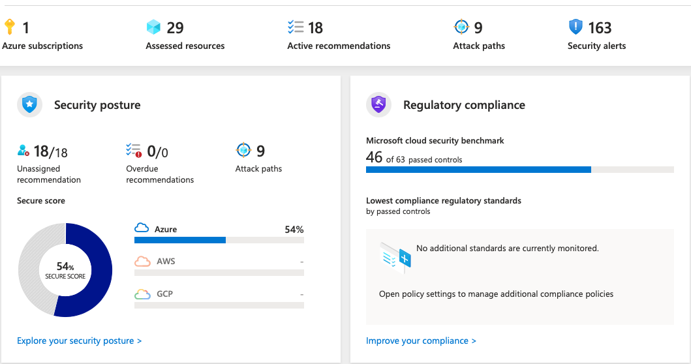
資訊安全首頁

2.4 | 費用警示 | 根據歷史用量資料，在評估優化後每月帳單金額，新增費用異常告警。
- 設置每月費用告警
- 每月費用超過NTD75,000
- 每月費用超過NTD120,000
- 每月預測費用將會超過180,000
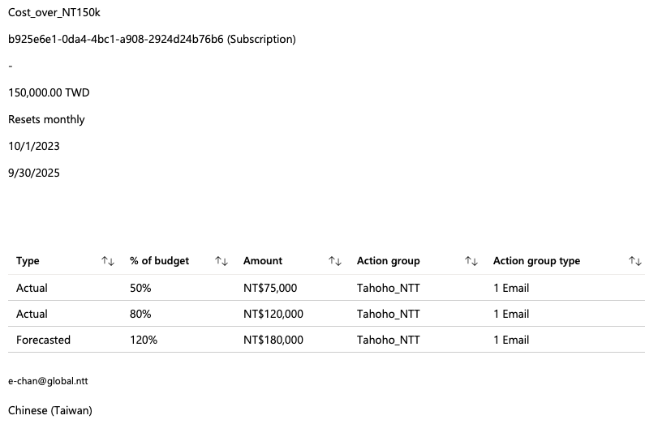

2. 設置email告警： e-chan@global.ntt

3 | 可視化 | 檢視每個雲端資源，確認用途及關連。
3.1 | 清理無用資源 | 列出無關聯之雲端資源，例如公用IP、網路介面、磁碟等清單，經達和確認後進行刪除作業。
Resource Name | Resource Group | Type | Status | Action
MSVMI-OnyxLogAnalyticWorkspace | onyxitlabresourcegroup | Data collection rule | no use | delete
flex26 | OnyxProductionGroup | NIC | no use | delete
moodle-nsg | OnyxITLabResourceGroup | NSG | no use | delete
Microsoft-VMInsights-Health-eastasia | onyxproductiongroup | Data collection rule | no use | delete

4 | Azure Backup | 目前有三個虛擬機器有執行備份作業，並未涵蓋所有虛擬機器以及磁碟資料，應通盤檢視所有需備份的資源並與使用者討論備份原則，資料留存期限，以及是否有法規需要遵循之資料保存。
4.1 | 資料備份 | - 確認所需備份之虛擬機器。  - 確認是否需要異地備份。  - 確認備份保存期限。
1. 一般備份規則DailyPolicy：日備份七份，週備份四份，月備份六份。
2. 進階備份規則EnhancedPolicy-lidv1e19：每日八點開始每四小時備份一次，持續十二小時。日備份七份，週備份四份，月備份六份。

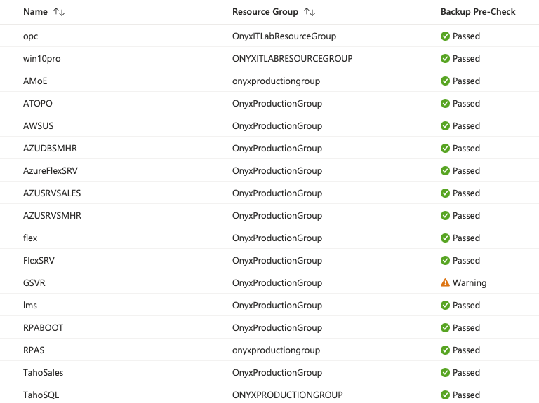

4.2 | 備份規則 | - 刪除不必要的備份設定。  - 設定備份失敗告警。
1. 設定備份失敗告警。

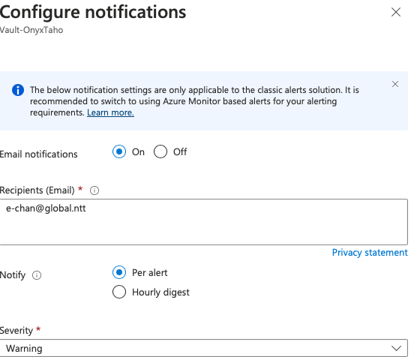

5 | 帳號管理 | 清查訂閱群組及帳號資訊
5.1 | 清除無用帳號 | 目前系統內有部分無用帳號，建議清除。
目前無權限進行帳號管理，由達和環保管理人員進行帳號管理。
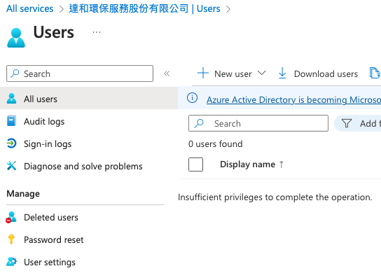

6 | 資訊安全 | 確認各系統安全配置及網路安全
6.1 | 網段存取 | 確認防火牆規則。
1. 部分防火牆規則已修改為限制來源端。
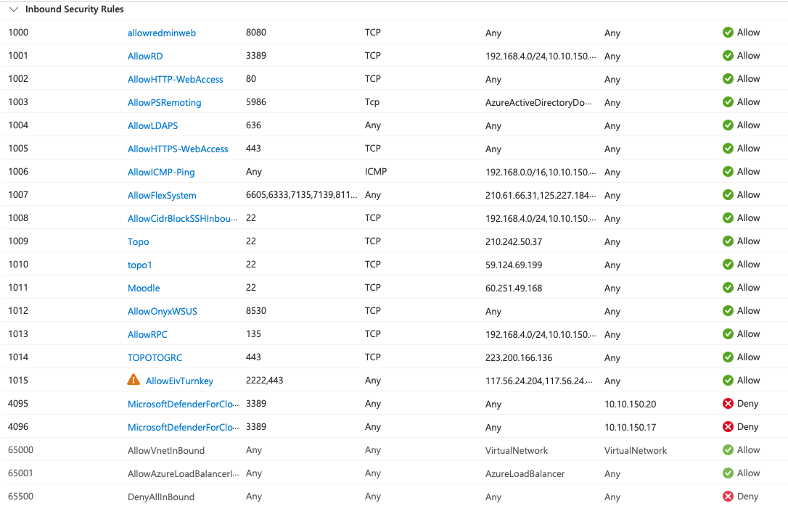

6.2 | 虛擬機器 | 確認虛擬機器安全性，包含defender及更新修補
- 所有虛擬機器都已啟用Defender for Cloud。
- 有兩台VM為安裝agent 將無法進行備份作業。

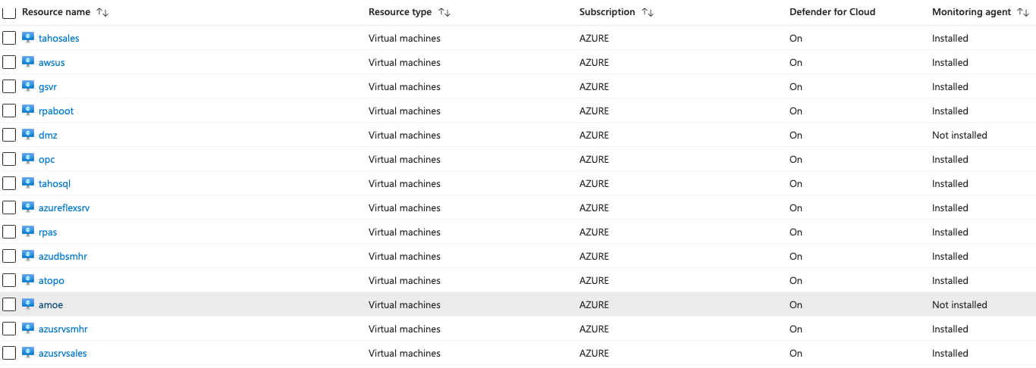

6.3 | 網路連線規則 | 確認公網存取權限及VPN設定。
1. 目前VPN架構已經調整。
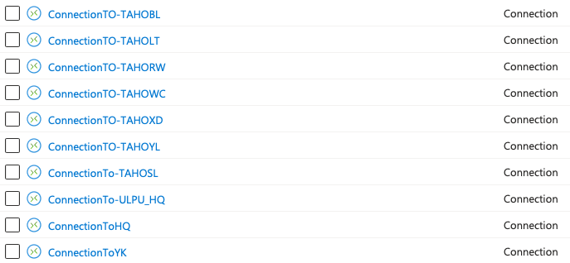

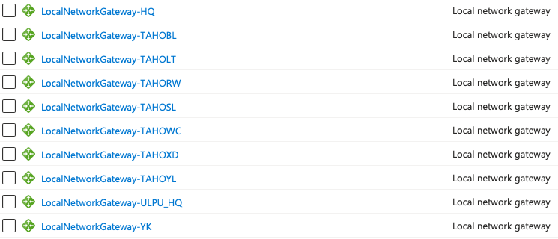

7 | 系統警示 | 確認系統警示項目
Microsoft Defender for Cloud Dashboard
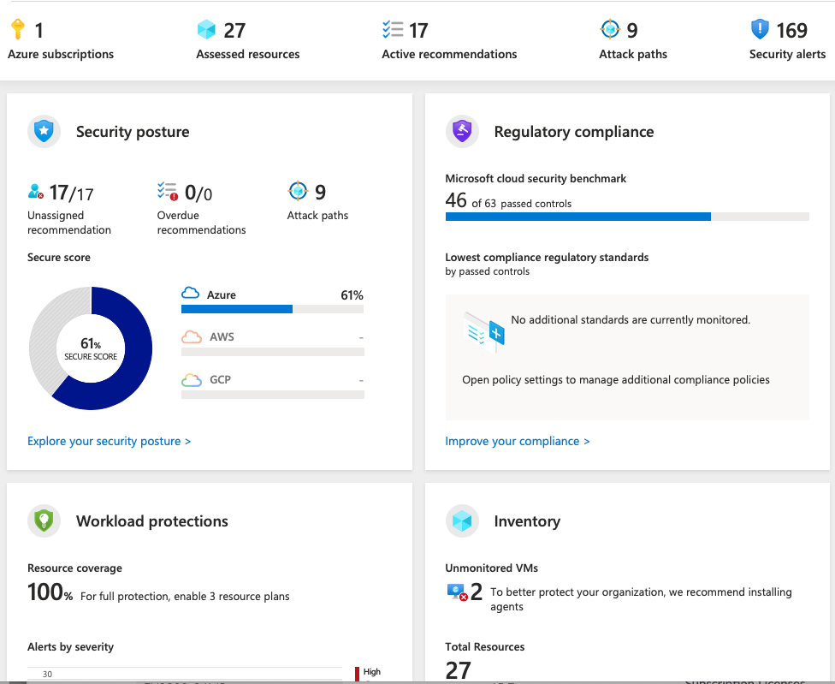

8 | 整體架構審視 | 全面審視雲端環境
8.1 | 費用分析 | 確認是否有需要調整及建議事項。
費用分析：

- 預估本月(2023/10)費用為台幣十六萬七千。
- 費用排名
服務名稱 | 金額 | 佔比
VM運算資源 | 51,208 | 0.306
VM作業系統授權 | 11,790 | 0.07
磁碟及儲存空間 | 11,017 | 0.065
VPN Gateway | 7,283 | 0.043
備份 | 6,791 | 0.04
Microsoft Defender | 6,126 | 0.036

- VM列表

VM名稱 | 規格 | 磁碟 | 建議方案
AMoe | D4lds v5  (4 vcpus, 8 GiB memory) | Standard SSD 30GB  Premium SSD 512GB | 調整為standard SSD
ATOPO | B2ms  (2 vcpus, 8 GiB memory) | Premium SSD 30GB  Premium SSD 128GB | 調整為standard SSD
AWSUS | D2as v4  (2 vcpus, 8 GiB memory) | Standard SSD 128GB  Premium SSD 256GB | 調整為standard SSD
AZUDBSMHR | D4s v3  (4 vcpus, 16 GiB memory) | Standard SSD 128GB  2*Premium SSD 128GB | 調整為standard SSD
AzureFlexSRV | D4ads v5  (4 vcpus, 16 GiB memory) | Standard SSD 128GB  Standard SSD 256GB
AZUSRVSALES | D4s v3  (4 vcpus, 16 GiB memory) | Standard HDD 30GB  Standard SSD 128GB | 調整為standard SSD
AZUSRVSMHR | D2as v4  (2 vcpus, 8 GiB memory) | Premium SSD 30GB  Standard HDD 64GB
DMZ | D2as v4  (2 vcpus, 8 GiB memory) | Standard HDD 30GB
GSVR | B2ms (2 vcpus, 8 GiB memory) | Standard HDD 128GB  Standard HDD 500GB
opc | D2as v4  (2 vcpus, 8 GiB memory) | Standard SSD 128GB
RPABOOT | E2s v3  (2 vcpus, 16 GiB memory) | Premium SSD 128GB  Premium SSD 50GB | 調整為standard SSD  增大虛擬機器規格
RPAS | E2s v3  (2 vcpus, 16 GiB memory) | Premium SSD 128GB  Premium SSD 64GB | 調整為standard SSD
TahoSales | D2as v4  (2 vcpus, 8 GiB memory) | Standard HDD 128GB | 調整為standard SSD
TahoSQL | D4s v3  (4 vcpus, 16 GiB memory) | Standard SSD 128GB  2*Standard SSD 256GB

- 部分機器採用高階 Premium SSD建議可調整為一般Standard SSD以節省經費。
- 根據效能告警警示，RPABOOT/AWSU經常發生CPU使用率超過90%，建議調整規格。
- 另外其他虛擬機器，不建議採用經常性定時resize的動作，因為resize作業會將虛擬器進行重置作業，長期定時重置會造成虛擬機器故障及資料遺失風險大增。 建議方案為增加機器規格並加入定時開關機即可同時滿足 1. 增加機器效能。 2. 節省經費。 3. 維持服務穩定以及資料不遺失。

8.2 | 網路架構 | 檢視是否有不合理之網路配置及建議。
1. 目前網路架構。
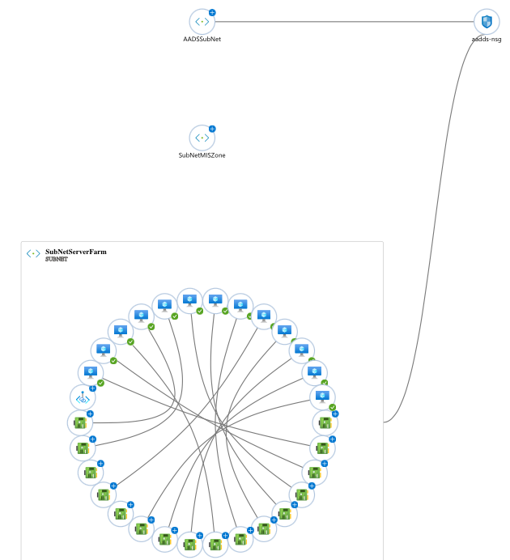

8.3 | 其他建議 | 其他於系統檢視過程當中發現之其他建議。
- AWSUS有提供對外網站服務，建議可改用Azure APP service提供網站服務，具有以下優點：
  - 託管服務，不須配置資安防護機制。
  - 節省費用，並且具有大效能低成本優點。
  - 內建高可用。

- 建議部分不採用定時開關機之虛擬機器，可以採用年約訂購以節省費用。
- 建議於建立新服務(虛擬機器)，可先與NTT進行需求確認以及協助建置作業。
- 目前效能告警以及每月費用告警將新增告警email告警對象為達和環保維護人員。
- 內部服務用之網站建議採用VPN聯通，不對外開放。
- PublicIPVNet IP address是動態IP，會有遺失風險，建議調整為靜態保留IP以利長期使用。
- 啟用資料庫備份：AZUDBSMHR/TahoSQL。

