
Cloud Optimization Project Plan
Managed Cloud & Infrastructure Services
27 April 2023 | Document Version V2

Version | Date | Comments
1 | 15 April 2023 | Initial release
2 | 27 April 2023 | 1. add action item  2. update schedule

NTT contact details
We welcome any enquiries regarding this document, its content, structure, or scope. Please contact:

NTT Taiwan Solutions Limited
Eric Chan – Senior Service Architect
Mobile:0910114111
Tel:02-21713365
eMail:e-chan@global.ntt

Confidentiality
This document contains NTT Limited ('NTT') confidential information. You may not disclose the confidential information to any third party without NTT’s written consent.



Table of Contents
NTT contact details 2
Confidentiality 2
1. Managed Cloud and Infrastructure Services (MCIS) 4
1.1. MCIS Portfolio Overview 4
2. Introduction 5
2.1. Technology Standards 6
2.2. Billing 6
3. Security and Compliance 7
3.1. Data Types and Protection 7
3.2. Information Security Incident Management 7
3.3. Company Standards and Certifications 7
4. Service Plan 8
4.1. Action Plan 8
4.2. Schedule 33
4.3. Action Item 33

Managed Cloud and Infrastructure Services (MCIS)
Systems running on hybrid cloud infrastructure (public cloud, private cloud, data center and co-location) must be monitored, measured, and reported on by staff who need to focus on delivering service to the business in addition to supporting technology.
NTT has developed its approach to managing hybrid IT with these factors in mind. Our managed services are focused on driving operational standards to manage the daily operations of Client infrastructures through:
- Building on a core of industry best-practice processes (ITIL, ISO27001)
- Driving automation to enable higher levels of availability and enable enhanced and consistent user experience
- Ensuring continual service improvement, and empowering Clients with the information to make business decisions about their IT environment through data collection, analysis, and dissemination
- Providing an integrated service delivery model with centralized service delivery combined with regional and country resources to provide support when and where needed
- Combining our cross-competencies in Cloud, DevOps, network, workplace and collaboration, data center and security to provide an integrated and standardized end to end managed service experience across the entire IT estate

MCIS Portfolio Overview
NTT has developed its portfolio of managed services (referred to in this document as the “Service”) to include the following:
- Managed Public Cloud
- Managed Private Cloud
- Managed Data Center & Networking Infrastructure
- Managed Application Infrastructure (OS, DB and Middleware)
- Managed Applications
- Managed Cloud Security & Managed SAP Security
- Managed End User Services
Each of these service offers contain multiple service offer options. Clients work with NTT to define requirements in Scope in the SOW for one or more service offer options so that a managed services solution can be deployed that meets technical and budgetary requirements.

Introduction
NTT has developed a Cloud Transformation Journey to support clients through their transition to our Managed Cloud and Infrastructure Services. Engagements begin by Assessing and Understanding the client's solution requirements to Advise on digital transformation and to Design a high-level architecture plan and transition roadmap. Designs are then further detailed and finalized, and transition plans are executed to onboard the client into the managed environment. Depending on scope, new systems are Deployed and/or existing systems are Migrated to supported managed services platforms. Operate services provide security, support and ongoing maintenance of the client’s systems while Optimize and Advisory services promote continuous improvement, cost efficiency and transformation.
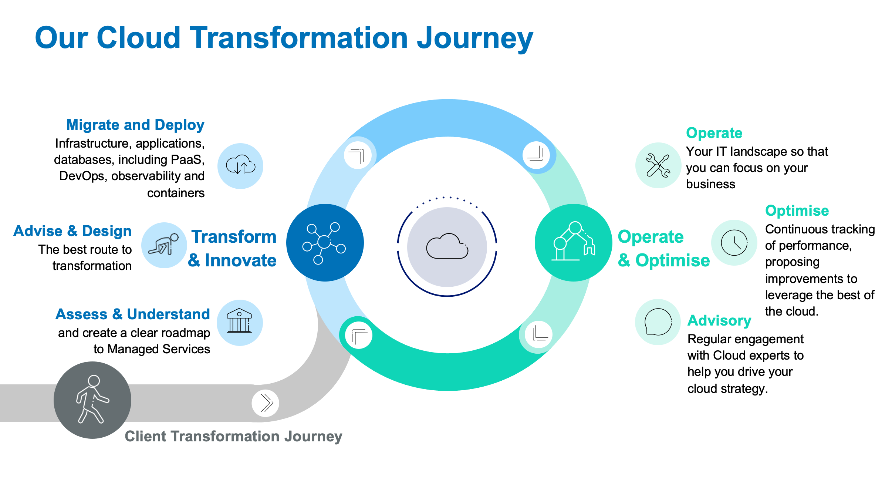
Figure 1 Our Cloud Transformation Strategy
The Cloud Transformation Journey is only provided for selected services that are In Scope for managed services in the SOW and cannot be provided on a standalone basis.

NTT MCIS can support systems running on the following platforms:
- Public Cloud (AWS, Azure, GCP)
- Private Cloud (VMware, Nutanix, Microsoft Azure Stack family)
- NTT Private Cloud
- Multi-Cloud (Private, Public and Hybrid Cloud)
- Traditional infrastructure on premises or in a co-located data center

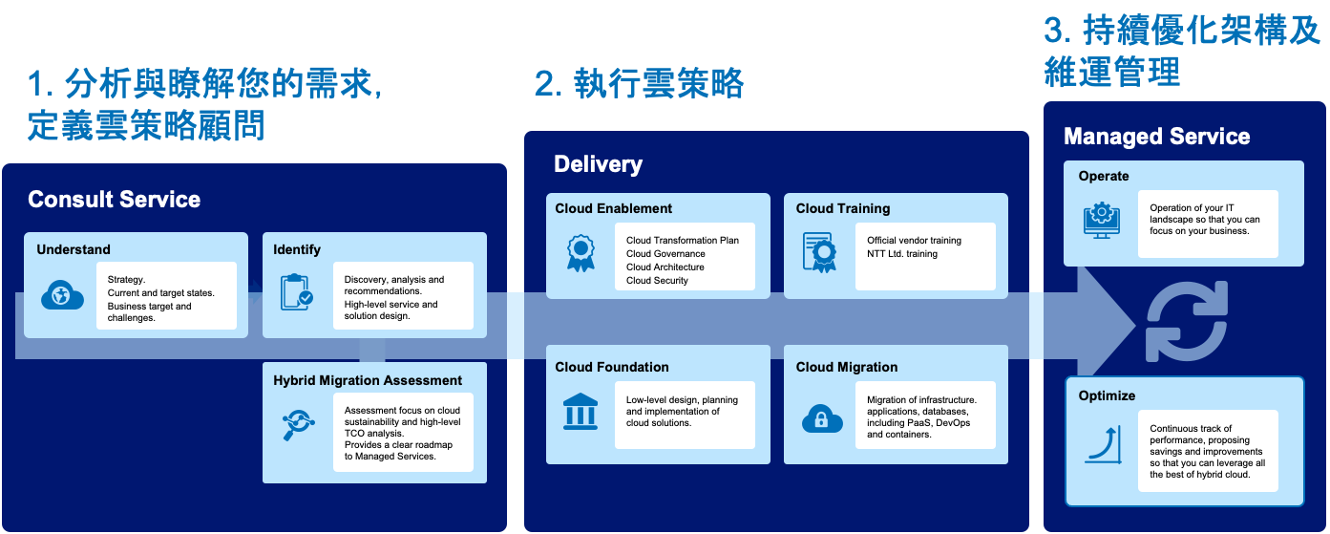

Technology Standards
NTT has developed standard offers for our entire service portfolio which provide specific monitoring configurations, Client requests and setup tasks for supported technologies. These technology specific standard offers are described in the MCIS Services Guide.

Billing
The client contracts for one or more service offers for each IT asset that is to be managed by NTT MCIS. Each IT component under management is referred to as a Configuration Item (“CI”). A configuration item (CI) is any service component that needs to be managed, such as a router, an operating system, or a database.
The client is billed monthly for each managed service contracted for the support of a service component as specified in the SOW.
For public cloud scalable assets, the client is billed only for the management of the base image and its software components (regardless from the number of servers deployed from it).
Public cloud PaaS, Serverless and Container solutions are billed based on the platforms used, use case, and complexity as specified in the SOW.

Security and Compliance

Data Types and Protection
NTT may process, store, or access the following types of data in delivery of the Client Service which shall be subject to the Agreement:
- Hosted data which resides in the managed Client environment
- Service data found in NTT systems (e.g., service tickets, documentation, billing, etc.)
NTT will protect hosted and service data in accordance with the SOW. This data may include but not be limited to subtypes or categories of data such as personal data, confidential information, configuration data, CMBD data, log data, or other controlled data subject to specific industry or government mandates.

Information Security Incident Management
NTT has policies, processes, and procedures for detecting, identifying, notifying appropriate stakeholders of, responding to, and recovering from information security incidents in the event of an information security incident, including personal data breaches. This includes mechanisms for performing a root cause analysis and undertaking corrective actions.

Company Standards and Certifications
NTT delivers comprehensive managed services while adhering to the highest level of industry-relevant and government standards. Information Technology Infrastructure Library (ITIL) and Control Objectives for Information Related Technologies (COBIT) are the foundation of our product and service offerings, resulting in alignment and certifications to the most common standards such as: ISO, CIS, and NIST. NTT operates a continuous improvement program with multiple standards integrated to support many industries
NTT has undertaken to obtain applicable security-related certifications for certain Services or Service components described in this Client Service Description, including ISO 27001. NTT can provide a copy of its associated certificates for the appropriate service division, where applicable, upon Client request.

Service Plan

Action Plan
編號 | 項目 | 執行說明
1 | Azure VM | 根據虛擬機器實際使用情況，調整規格以符合實際運算需求。
1.1 | 虛擬機規格調整 | - 檢視虛擬機資源使用率報表。  - 確認虛擬機是否需要調整規格。  - 建議是否採用RI年約以降低費用。
AzureFlexSRV: Standard D4s v3 (4 vCPUs, 16 GB memory), Premium SSD LRS 128GB, Premium SSD LRS 512GB
3/19-4/16 CPU平均使用率:低於8%
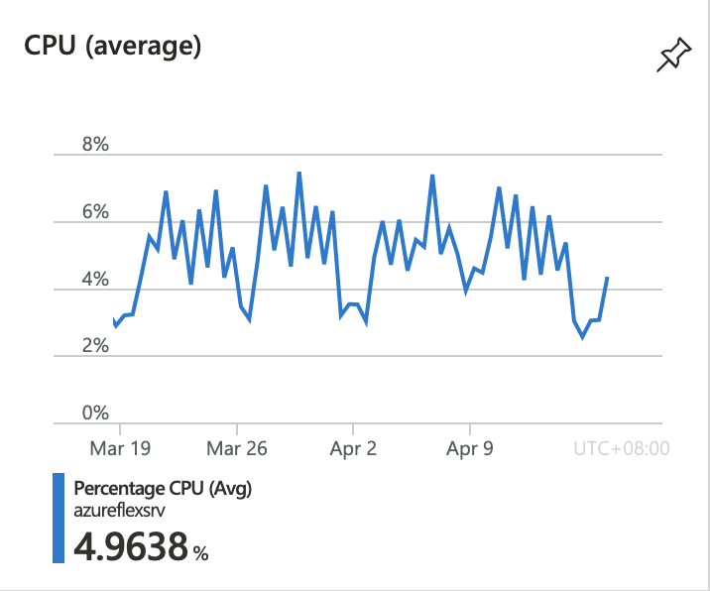

3/19-4/16 Memory平均剩餘13.xGB, 總共16GB
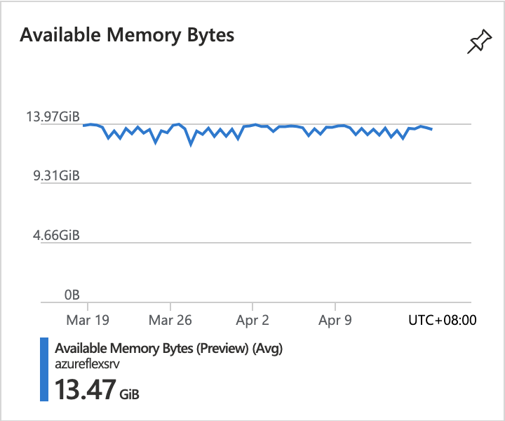

3/19-4/16 Disk IOPS平均低於5
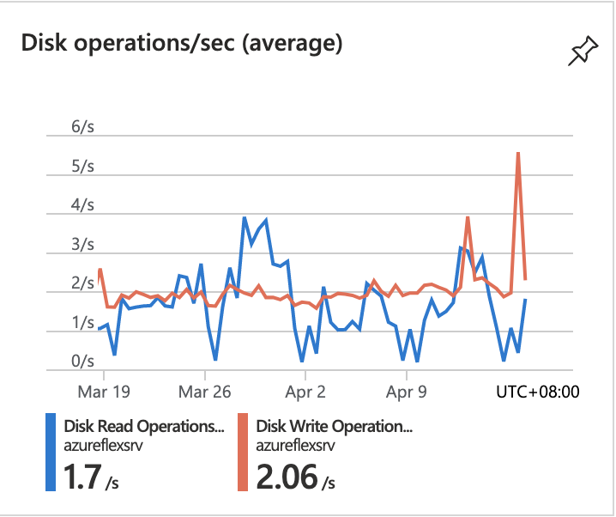

DMZ：Standard D2as v4 (2 vCPUs, 8 GB memory), Standard HDD LRS 30GB
3/19-4/16 CPU平均使用率:低於1%
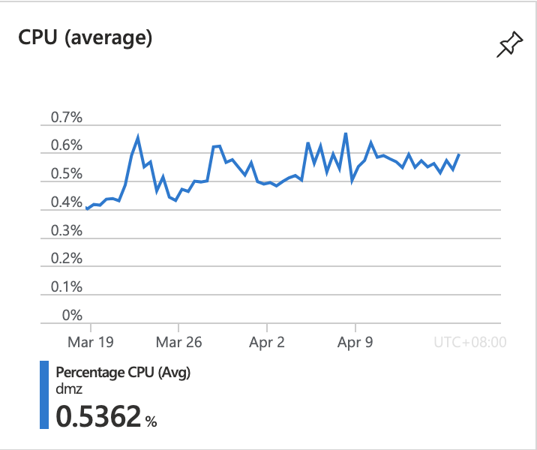

3/19-4/16 Memory平均剩餘5GB, 總共8GB
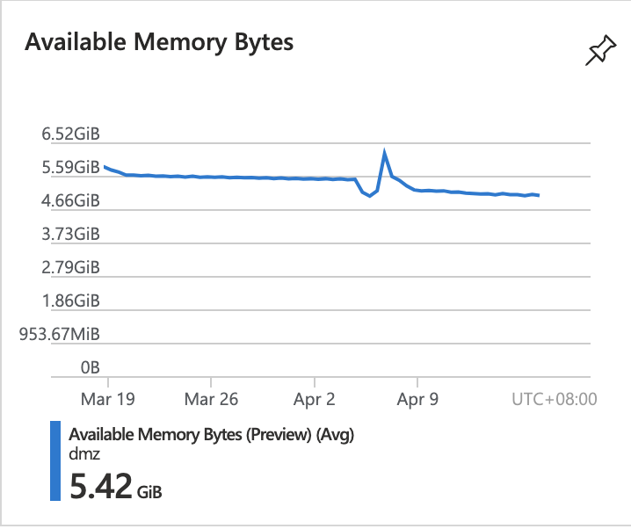

3/19-4/16 Disk IOPS平均約10
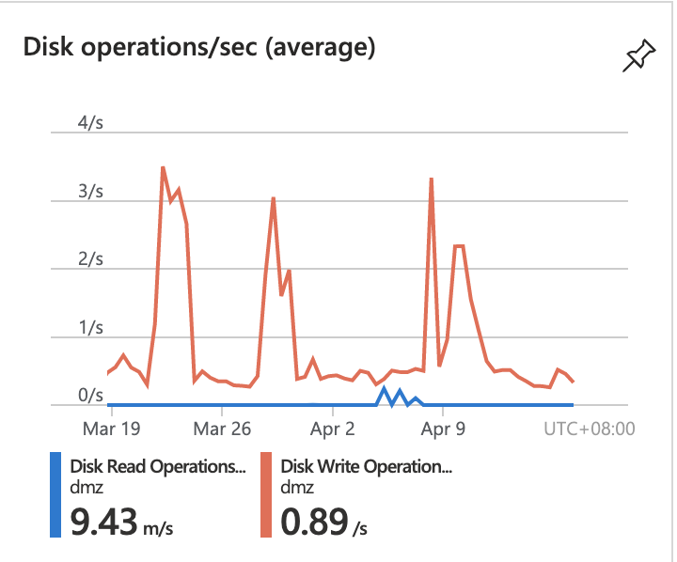

GSVR：Standard B2ms (2 vCPUs, 8 GB memory), Standard HDD LRS 128GB, Standard HDD LRS 500GB
3/19-4/16 CPU平均使用率:低於8%
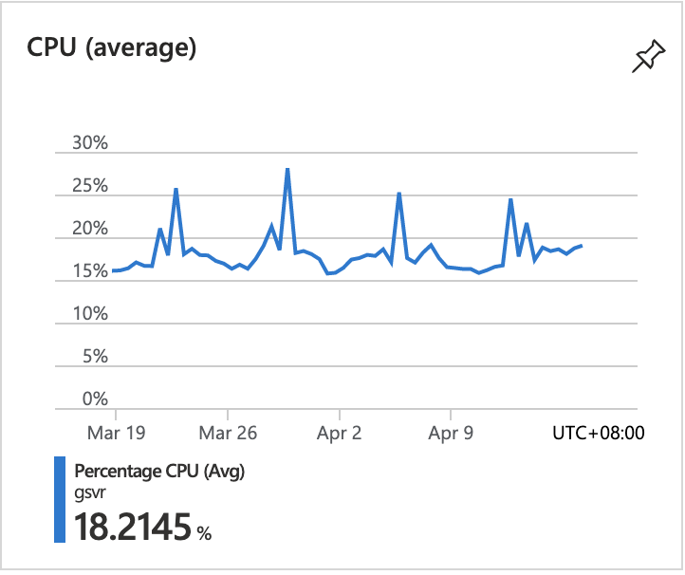

3/19-4/16 Memory平均剩餘1.5GB, 總共8GB
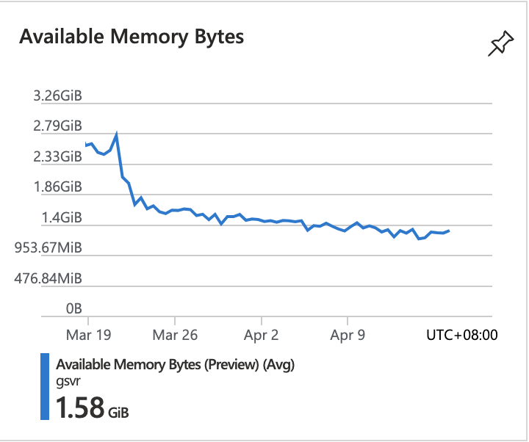

3/19-4/16 Disk IOPS平均約10
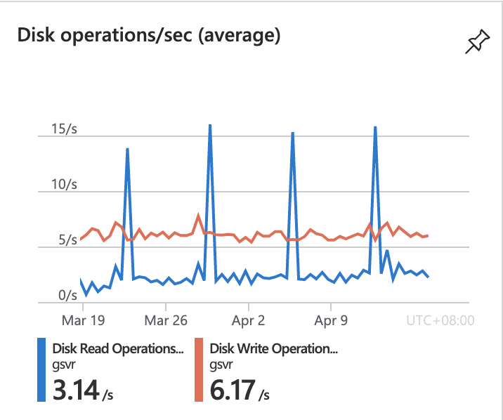

Ims：Standard B4ms (4 vCPUs, 16 GB memory), Premium SSD LRS 128GB, Premium SSD LRS 1TB

3/19-4/16 CPU平均使用率:低於8%
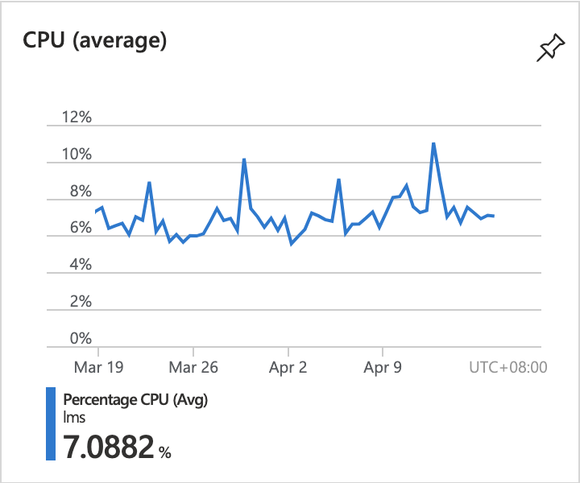

3/19-4/16 Memory平均剩餘11GB, 總共16GB
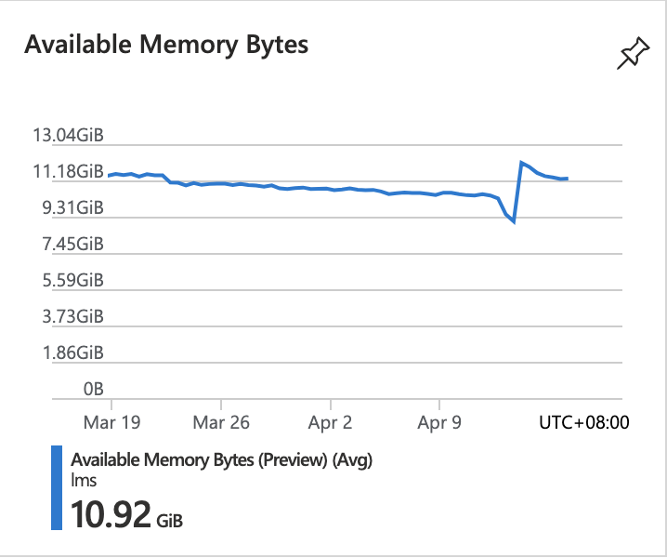

3/19-4/16 Disk IOPS平均約5.x
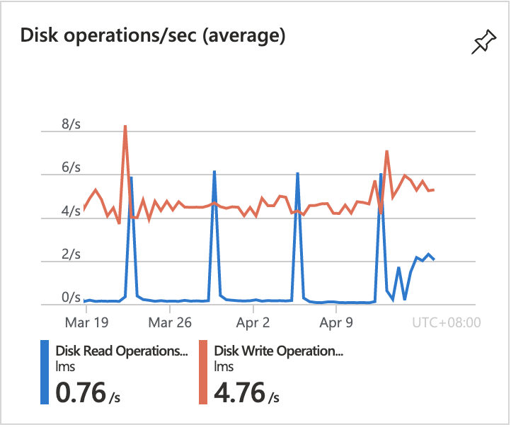

opc：Standard B4ms (4 vCPUs, 16 GB memory), Premium SSD LRS 128GB

3/19-4/16 CPU平均使用率:低於3%
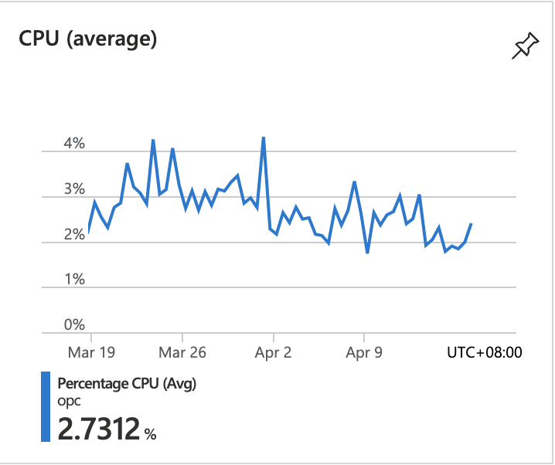

3/19-4/16 Memory平均剩餘11.xGB, 總共16GB
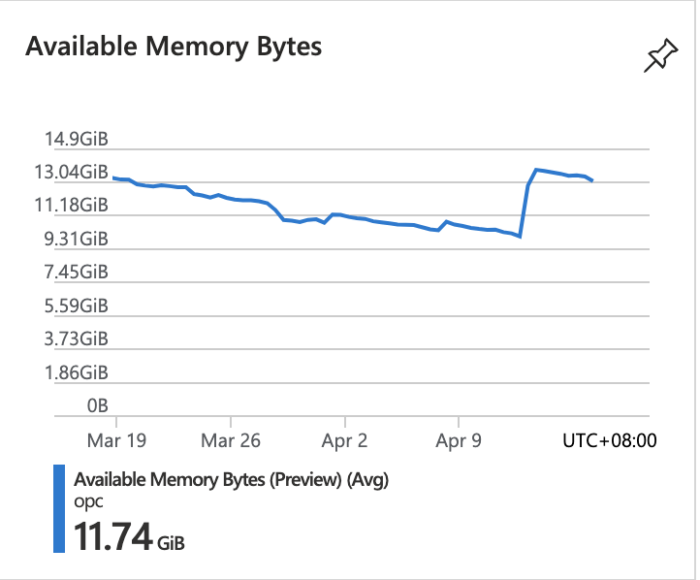

3/19-4/16 Disk IOPS平均約4
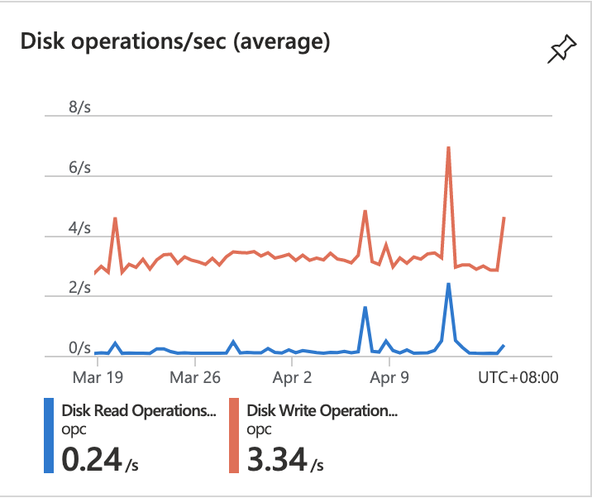

TahoSales：Standard D4s v3 (4 vCPUs, 16 GB memory), Standard HDD LRS 128GB
3/19-4/16 CPU平均使用率:低於3%
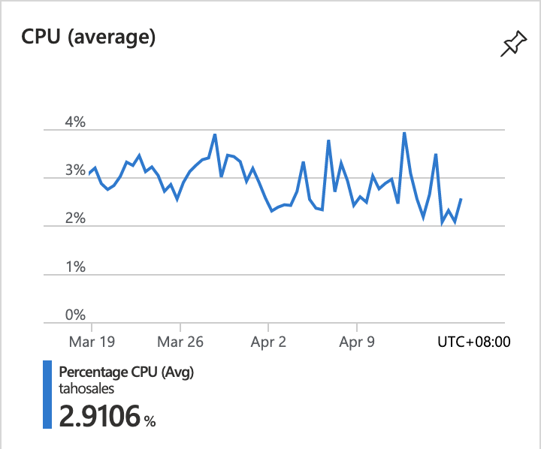

3/19-4/16 Memory平均剩餘11.xGB, 總共16GB
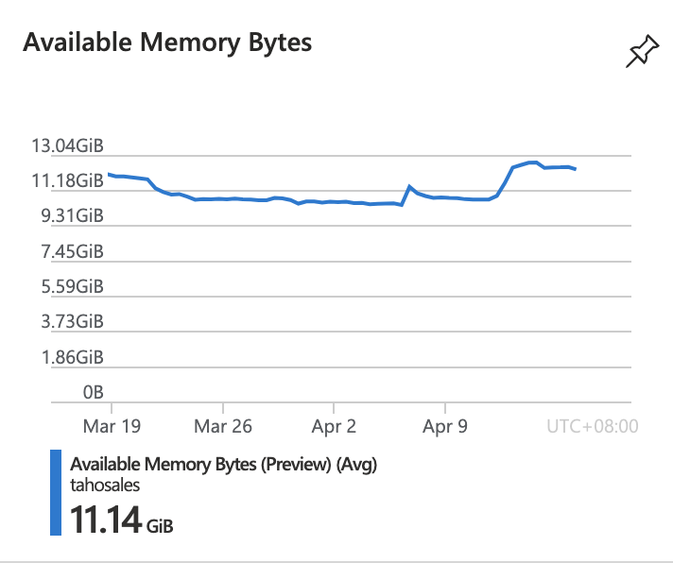

3/19-4/16 Disk IOPS平均約5
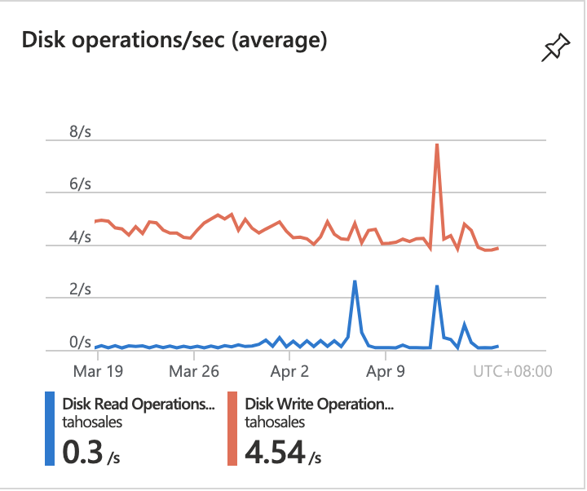

TahoSQL：Standard D4s v3 (4 vCPUs, 16 GB memory), Premium SSD LRS 128GB, 2* Premium SSD LRS 1TB
3/19-4/16 CPU平均使用率:低於8%
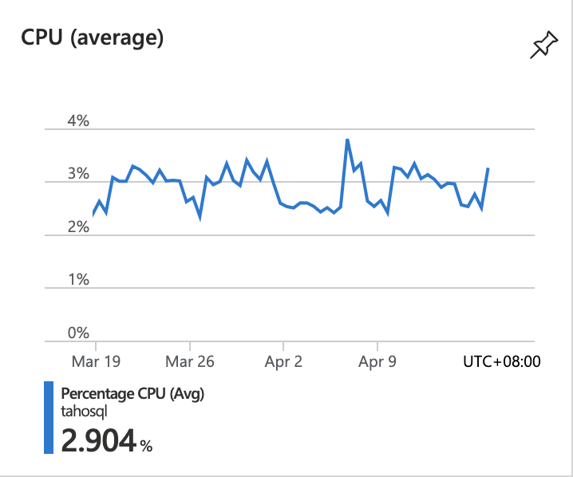

3/19-4/16 Memory平均剩餘10.xGB, 總共16GB
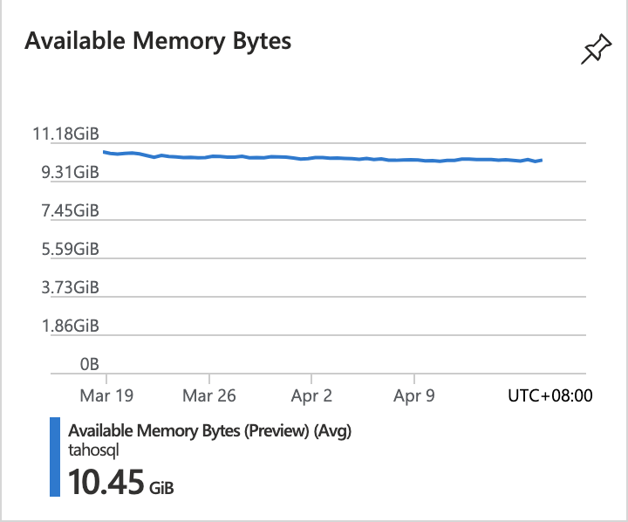

3/19-4/16 Disk IOPS平均約10
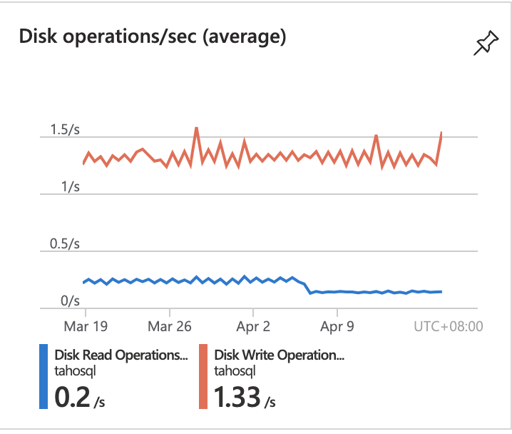

Summary：
Monthly Cost：65,871

VM Name | Specification | Disk | Cost (month)
AzureFlexSRV | Standard D4s v3  (4 vCPUs, 16 GB memory) | Premium SSD LRS 128GB Premium SSD LRS 512GB | (VM)9,953 + (Disk)659 + 2,451 = 13,063
DMZ | Standard D2as v4  (2 vCPUs, 8 GB memory) | Standard HDD LRS 30GB | (VM)2,932 + (Disk)46 = 2,978
GSVR | Standard B2ms  (2 vCPUs, 8 GB memory) | Standard HDD LRS 128GB Standard HDD LRS 500GB | (VM)2,599 + (Disk)179 + 662 = 3,440
Ims | Standard B4ms  (4 vCPUs, 16 GB memory) | Premium SSD LRS 128GB Premium SSD LRS 1TB | (VM)5,554 + (Disk)659 + 4,525 = 10,738
opc | Standard B4ms  (4 vCPUs, 16 GB memory) | Premium SSD LRS 128GB | (VM)5,199 + (Disk)659 = 5,858
TahoSales | Standard D4s v3  (4 vCPUs, 16 GB memory) | Standard HDD LRS 128GB | (VM)9,953 + (Disk)179 = 10,132
TahoSQL | Standard D4s v3  (4 vCPUs, 16 GB memory) | Premium SSD LRS 128GB, 2* Premium SSD LRS 1TB | (VM)9953 + (Disk)659 + 4525 + 4525 = 19,662
建議方案：
一、降低VM規格：根據監控效能資料，資源使用率偏低，建議降低 VM規格避免費用浪費。
二、降低硬碟規格：根據監控效能資料，硬碟使用率偏低，建議從Premium SSD降為Standard SSD。
三、降低硬碟大小：需Tahaha協助登入VM確認硬碟容量使用率，若使用率偏低則可以使用小容量硬碟以節省費用。
四、設定定時開關機：若離峰時間不使用服務，可設定自動開關機以節省費用。

方案一、二：
Monthly Cost：30,604
每月節省：65,871-30,604=35,267
每年節省：35,267x12=423,204
VM Name | Specification | Disk | Cost (month)
AzureFlexSRV | Standard D2as v4  (2 vCPUs, 8 GB memory) | Standard SSD LRS 128GB Standard SSD LRS 512GB | (VM)2,932 + (Disk)292 + 1,168 = 4,392
DMZ | Standard D2as v4  (2 vCPUs, 8 GB memory) | Standard HDD LRS 30GB | (VM)2,932 + (Disk)46 = 2,978
GSVR | Standard B2ms  (2 vCPUs, 8 GB memory) | Standard HDD LRS 128GB Standard HDD LRS 500GB | (VM)2,599 + (Disk)179 + 662 = 3,440
Ims | Standard D2as v4  (2 vCPUs, 8 GB memory) | Standard SSD LRS 128GB Standard SSD LRS 1TB | (VM)2,932 + (Disk)292 + 2,337 = 5,561
opc | Standard D2as v4  (2 vCPUs, 8 GB memory) | Standard SSD LRS 128GB | (VM)2,932 + (Disk)292 = 3,224
TahoSales | Standard D2as v4  (2 vCPUs, 8 GB memory) | Standard HDD LRS 128GB | (VM)2,932 + (Disk)179 = 3,111
TahoSQL | Standard D2as v4  (2 vCPUs, 8 GB memory) | Standard SSD LRS 128GB, 2* Standard SSD LRS 1TB | (VM)2,932 + (Disk)292 + 2,337 + 2,337 = 7,898

方案三：在方案一二的基礎下，降低硬碟容量
M Name | Specification | Disk | Cost (month)
AzureFlexSRV | Standard D2as v4  (2 vCPUs, 8 GB memory) | Standard SSD LRS 128GB Standard SSD LRS 256GB | (VM)2,932 + (Disk)292 + 584 = 3,808
DMZ | Standard D2as v4  (2 vCPUs, 8 GB memory) | Standard HDD LRS 30GB | (VM)2,932 + (Disk)46 = 2,978
GSVR | Standard B2ms  (2 vCPUs, 8 GB memory) | Standard HDD LRS 128GB Standard HDD LRS 256GB | (VM)2,599 + (Disk)179 + 344 = 3,122
Ims | Standard D2as v4  (2 vCPUs, 8 GB memory) | Standard SSD LRS 128GB Standard SSD LRS 256GB | (VM)2,932 + (Disk)292 + 584 = 3,808
opc | Standard D2as v4  (2 vCPUs, 8 GB memory) | Standard SSD LRS 128GB | (VM)2,932 + (Disk)292 = 3,224
TahoSales | Standard D2as v4  (2 vCPUs, 8 GB memory) | Standard HDD LRS 128GB | (VM)2,932 + (Disk)179 = 3,111
TahoSQL | Standard D2as v4  (2 vCPUs, 8 GB memory) | Standard SSD LRS 128GB, 2* Standard SSD LRS 256GB | (VM)2,932 + (Disk)292 + 584 + 584 = 4,392
Monthly Cost：24,443
每月節省：30,604-24,443=6,161
每年節省：6,161x12=73,932

方案四：在方案一二三的基礎下，使用自動開關機，假設週一~週五 07:00-20:00為開機時段，剩餘時間關閉VM，費用為目前7x24開機的40%，為24,443x0.4=每月9,777，每年117,326

 | 每月費用 | 每月節省 | 每年節省 | 每年總費用
原始方案 | 65,871 | 0 | 0 | 790,452
方案一二 | 30,604 | 35,267 | 423,204 | 367,248
方案三 | 24,443 | 6,161 | 73,932 | 293,316
方案四 | 9,777 | 14,666 | 175,992 | 117,324
總計 |  | -56,094 |  | -673,128

備註：以上只是虛擬機器費用，完整費用須包含其他項目。

2 | 告警配置 | - 目前已經建立三個Log Analytics工作區，但無實際執行作業。  - 刪除無用的工作區。  - 新增須監控之標的物，例如VM。  - 設定監控項目，例如VM CPU使用率。  - 設定告警項目並通知必須要人員。
2.1 | 刪除無用的工作區 | 刪除無用的Log Analytics
保留OnyxLogAnalyticWorkspace，移除另外兩個Log Analytics工作區。
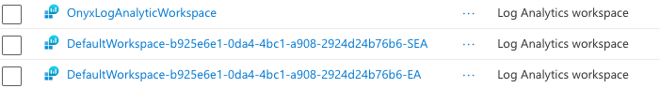

2.2 | 配置效能告警 | - 確認收集效能資料。  - 確認Log保留期限。  - 配置告警項目，確認告警項目：CPU/Memory/Disk/Network，定義告警閥值。  - 確認告警通知對象(email)
1. 針對七個VM配置告警項目：
- CPU使用率：90%
- Disk IOPS使用率：80%
- 剩餘記憶體：1GB
- 網路流量：100MB
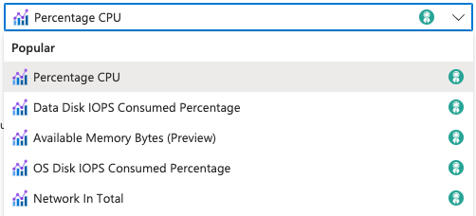

2. 設置email告警： joy.liao@tahoho.com.tw

2.3 | 資訊安全告警 | 設置Microsoft Defender for Cloud
1. 確認七個VM啟用進階安全防護。
2. 檢視目前766個資安告警項目內容，確認是否需進階分析及改進。

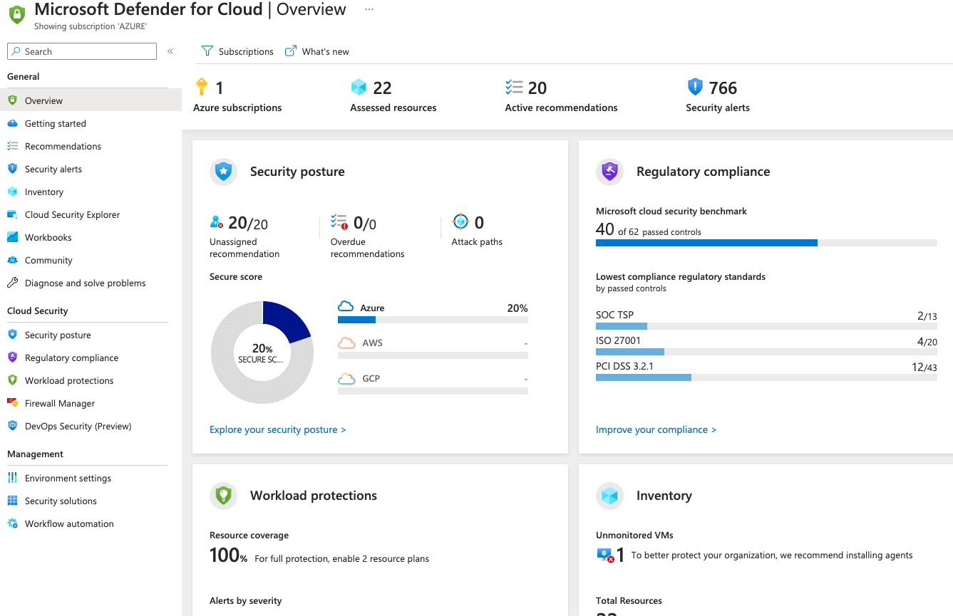

2.4 | 費用警示 | 根據歷史用量資料，在評估優化後每月帳單金額，新增費用異常告警。
待資源重整作業完成後，觀察單月費用後，設置費用使用率告警。
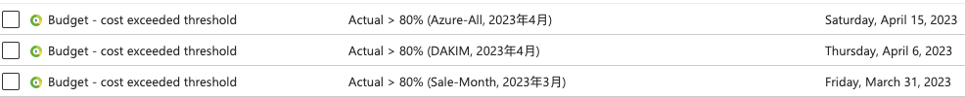

3 | 可視化 | 檢視每個雲端資源，確認用途及關連。
3.1 | 清理無用資源 | 列出無關聯之雲端資源，例如公用IP、網路介面、磁碟等清單，經達和確認後進行刪除作業。
因表格格式不相容，置放於本表下方。

3.2 | 標籤整理 | 目前系統內已經有使用resource group進行資源的分類，此部分不調整，僅針對各系統元件進行標籤整理。
標籤歸類：
1. VM: VMname
2. Service:backup/monitor

4 | Azure Backup | 目前有三個虛擬機器有執行備份作業，並未涵蓋所有虛擬機器以及磁碟資料，應通盤檢視所有需備份的資源並與使用者討論備份原則，資料留存期限，以及是否有法規需要遵循之資料保存。
4.1 | 資料備份 | - 確認所需備份之虛擬機器。  - 確認是否需要異地備份。  - 確認備份保存期限。
1. 設定VM備份：日備份七份，週備份兩份。

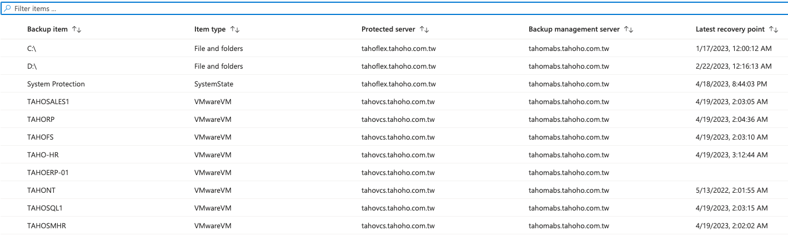

2. 目前備份保留時間過長(180天日備份)，佔據過多磁碟空間。
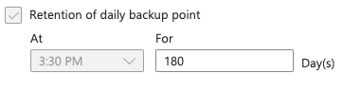

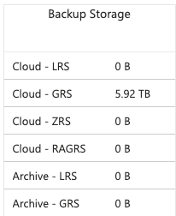

4.2 | 備份規則 | - 刪除不必要的備份設定。  - 設定備份失敗告警。
1. 設定備份失敗告警。
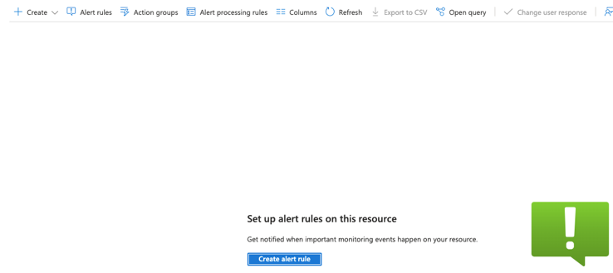

4.3 | 還原測試 | - 虛擬機備份還原測試。  - 虛擬機開機測試。
1. 新建resource group作為還原測試。
2. 使用本機測試，測試方法需與tahoho討論實際執行步驟。
3. 建議搭配自動開關機測試進行。

5 | 帳號管理 | 清查訂閱群組及帳號資訊
5.1 | 清除無用帳號 | 目前系統內有部分無用帳號，建議清除。
1. 建議清除部分無用帳號。
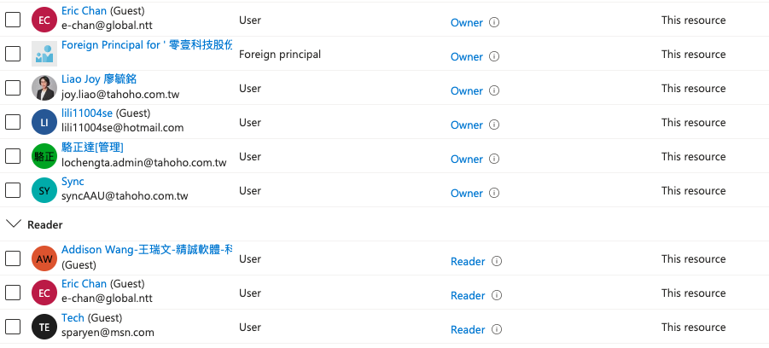

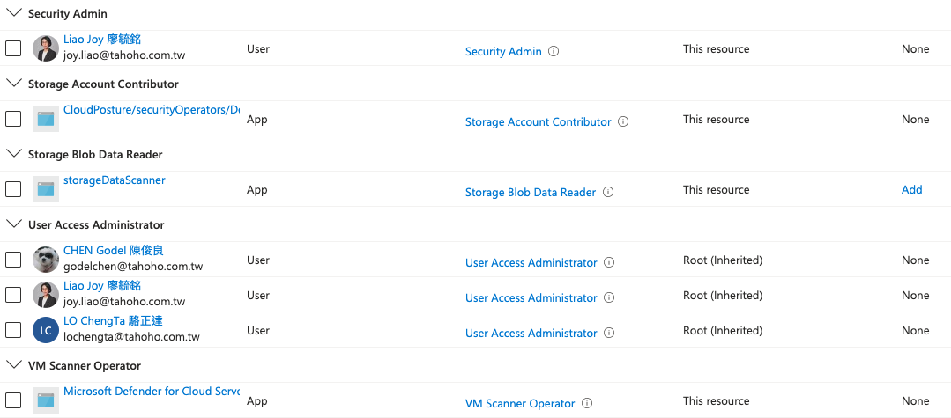
6 | 資訊安全 | 確認各系統安全配置及網路安全
6.1 | 網段存取 | 確認防火牆規則。
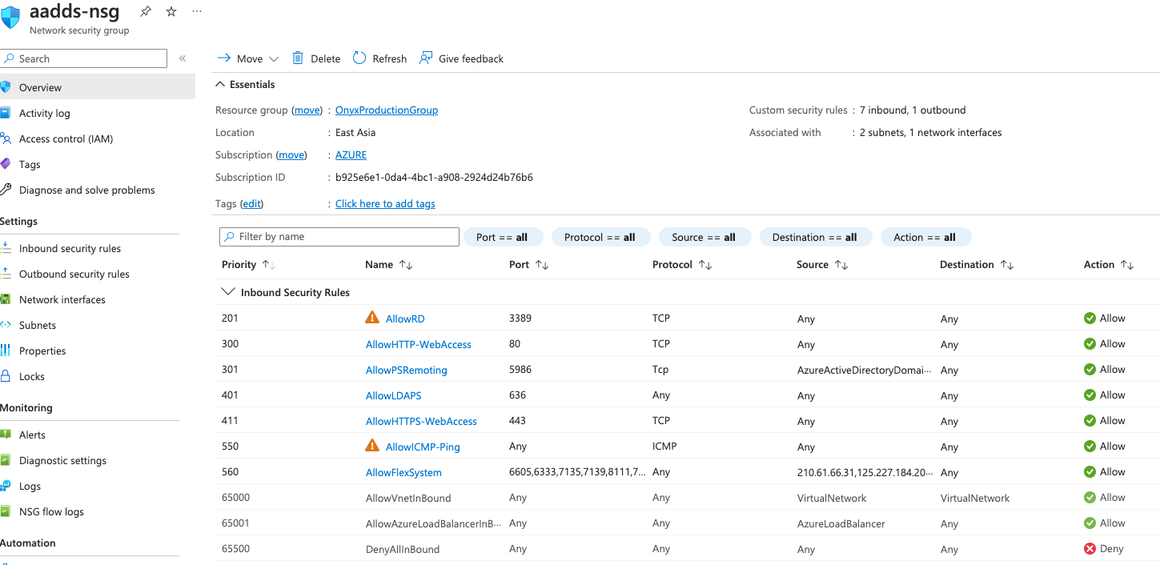
1. 有部分防火牆規則允許any to any，若有需要請限制來源端IP。

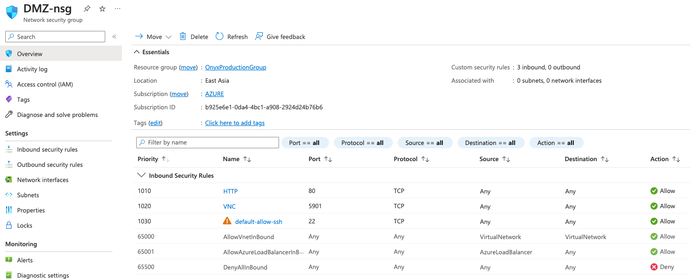

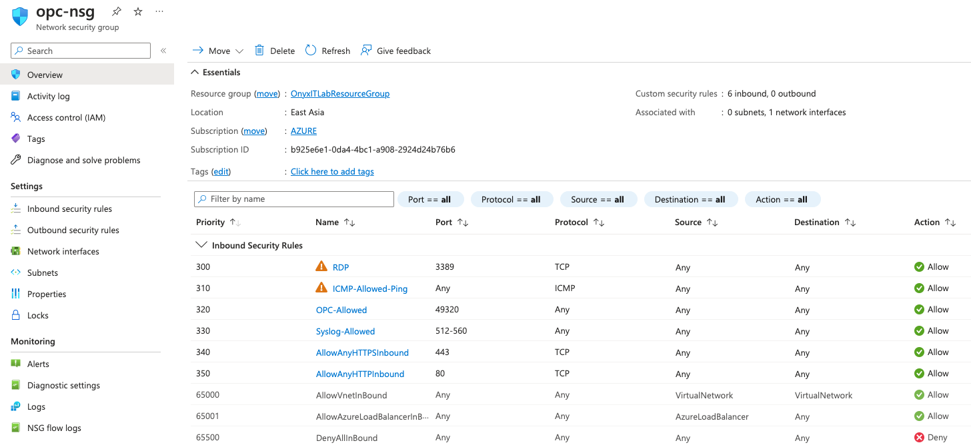

2. 需確認此NSG是否還需要。
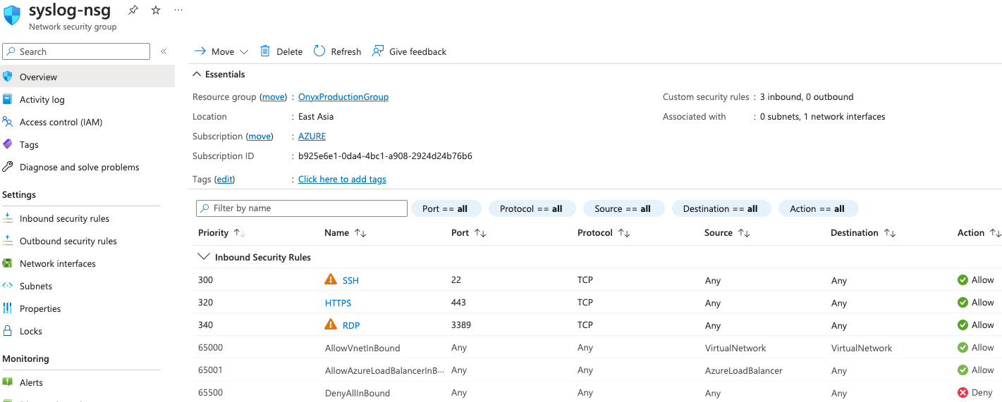

6.2 | 虛擬機器 | 確認虛擬機器安全性，包含defender及更新修補
1. 建議啟用進階安全防護，檢視系統威脅。
2. DMZ為安裝agent，是否需要安裝(linux)

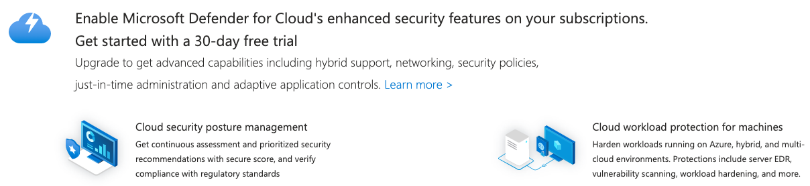

6.3 | 網路連線規則 | 確認公網存取權限及VPN設定。
1. 確認是否只保留一組VPN連線。
2. 是否降低VPN規格以節省費用。

7 | 系統警示 | 確認系統警示項目
7.1 | MFA | 系統警示：即將淘汰 MFA 伺服器，請在 2024 年 9 月前從 MFA Server 移轉至 Azure AD Multi-Factor Authentication，以避免任何服務影響。  建議另行安排時間進行移轉作業，須清查是否有第三方應用程式以第三方組織目前需有使用需求，妥善評估安排移轉作業。
7.2 | TLS 1.2 | 系統警示：TLS 1.0、1.1 和 3DES 即將淘汰，請在用戶端 (應用程式/平台) 上啟用對 TLS 1.2 的支援，以避免造成任何服務影響。
7.3 | 其他 | 確認是否有其他系統警示需要特定作業處置。
1. 系統管理員帳號是否需要啟動兩階段驗證機制。
2. 評估是否導入第三方Manage EndPoint 保護機制。

8 | 整體架構審視 | 全面審視雲端環境
8.1 | 費用分析 | 確認是否有需要調整及建議事項。
費用佔比排名：
1. VM (建議調降規格)
2. Storage (建議調降規格及刪除無用空間)
3. 調整備份策略。
4. 調降VPN 規格。

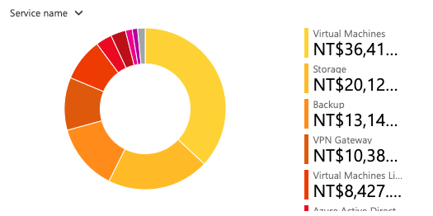

8.2 | 網路架構 | 檢視是否有不合理之網路配置及建議。
1. 目前網路架構還算單純，依照前述刪除無用資源以及檢視防火牆規則。
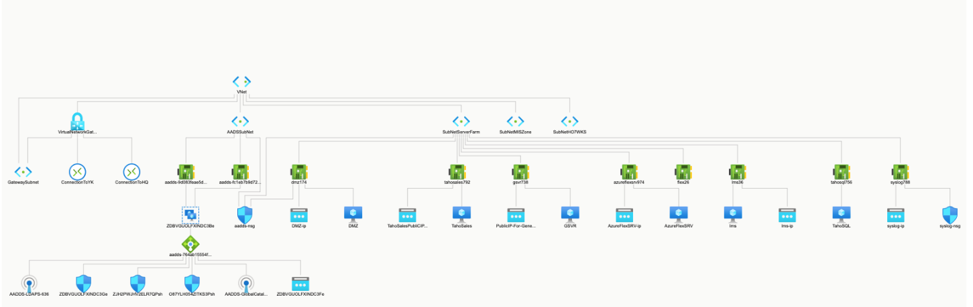

8.3 | 其他建議 | 其他於系統檢視過程當中發現之其他建議。
1. PublicIPforVNet (IP)於維護作業時應調整為固定IP。

3.1 清理無用資源元件
Resource Name | Resource Group | Type | Status | Action
azurevm | onyxitlabresourcegroup | API connection | no use | delete
Automate-b925e6e1-0da4-4bc1-a908-2924d24b76b6-EA | DefaultResourceGroup-EA | Automation Account | no use | delete
ConnectionToYK | onyxitlabresourcegroup | Site to Site VPN | no connection | delete
MSVMI-OnyxLogAnalyticWorkspace | onyxitlabresourcegroup | Data collection rule | no use | delete
Hubgrade | onyxitlabresourcegroup | IoT Hub | no use | delete
LocalNetworkGateway-YK | OnyxProductionGroup | VPN Local GW | no use | delete
LocalNetworkGatewayForHubgradeJiaYi | OnyxProductionGroup | VPN Local GW | no use | delete
flex26 | OnyxProductionGroup | NIC | no use | delete
FortiManager-NIC0 | OnyxITLabResourceGroup | NIC | no use | delete
moodle-nsg | OnyxITLabResourceGroup | NSG | no use | delete
NetworkWatcher_eastasia | NetworkWatcherRG | Network Watcher | no use | delete
IotPrivatePoint | OnyxITLabResourceGroup | Private endpoint | no use | delete
AzureMigrate0039vault | OnyxITLabResourceGroup | Recovery Services vault | no use | delete
Microsoft-VMInsights-Health-eastasia | onyxproductiongroup | Data collection rule | no use | delete
FortiManager-NIC0 | OnyxITLabResourceGroup | NIC | no use | delete
IotPrivatePoint.nic.74d8ba1e-680e-4dbc-b0d0-57dd47ee3411 | OnyxITLabResourceGroup | NIC | attach to IoTPrivatPoint
syslog788 | OnyxProductionGroup | NIC | attach to syslog-nsg
FortiManager-NSG | OnyxITLabResourceGroup | NSG | no use | delete
syslog-nsg | OnyxProductionGroup | NSG | suggest to delete
IotPrivatePoint | OnyxITLabResourceGroup | Private endpoint | no use | delete
FortiManager-PublicIP | OnyxITLabResourceGroup | IP | no use | delete
TestingFlexCopy-pip-7ff8666431c24cfcb30ee4e8f83b50ac | OnyxITLabResourceGroup | IP | no use | delete
flexrestort-pip-05de5e189e7545ca88e0b679a1e4f4f8 | OnyxITLabResourceGroup | IP | no use | delete
syslog-ip | OnyxProductionGroup | IP | no use | delete
AzureBackup_flexsrv_2026954084556127108 | AzureBackupRG_eastasia_1 | Restore Point Collection | no use | delete
AzureBackup_flex_2026954085278892928  Restore Point Collection | AzureBackupRG_eastasia_1 | Restore Point Collection | no use | delete
SQLAdvancedThreatProtection(DefaultWorkspace-b925e6e1-0da4-4bc1-a908-2924d24b76b6-SEA) | DefaultResourceGroup-SEA | Solution | no use | delete
SQLVulnerabilityAssessment(DefaultWorkspace-b925e6e1-0da4-4bc1-a908-2924d24b76b6-SEA) | DefaultResourceGroup-SEA | Solution | no use | delete
Security(DefaultWorkspace-b925e6e1-0da4-4bc1-a908-2924d24b76b6-SEA) | DefaultResourceGroup-SEA | Solution | no use | delete
SecurityCenterFree(DefaultWorkspace-b925e6e1-0da4-4bc1-a908-2924d24b76b6-SEA) | DefaultResourceGroup-SEA | Solution | no use | delete
ChangeTracking(defaultworkspace-b925e6e1-0da4-4bc1-a908-2924d24b76b6-ea) | defaultresourcegroup-ea | Solution | no use | delete
SQLAdvancedThreatProtection(DefaultWorkspace-b925e6e1-0da4-4bc1-a908-2924d24b76b6-EA) | defaultresourcegroup-ea | Solution | no use | delete
SQLVulnerabilityAssessment(DefaultWorkspace-b925e6e1-0da4-4bc1-a908-2924d24b76b6-EA) | defaultresourcegroup-ea | Solution | no use | delete
Security(DefaultWorkspace-b925e6e1-0da4-4bc1-a908-2924d24b76b6-EA) | defaultresourcegroup-ea | Solution | no use | delete
SecurityCenterFree(DefaultWorkspace-b925e6e1-0da4-4bc1-a908-2924d24b76b6-EA) | defaultresourcegroup-ea | Solution | no use | delete
SecurityCenterFree(OnyxLogAnalyticWorkspace) | onyxitlabresourcegroup | Solution | no use | delete
SecurityInsights(onyxloganalyticworkspace) | onyxitlabresourcegroup | Solution | no use | delete
VMInsights(onyxloganalyticworkspace) | onyxitlabresourcegroup | Solution | no use | delete
cs110032000bee7f7e2 | cloud-shell-storage-southeastasia | Storage account | need to check
azureapp-auto-alerts-d81372-joy_liao_tahoho_com_tw |  | resource group | no use | delete
cloud-shell-storage-southeastasia |  | resource group | no use | delete
DefaultResourceGroup-EA |  | resource group | no use | delete
DefaultResourceGroup-SEA |  | resource group | no use | delete
NetworkWatcherRG |  | resource group | no use | delete

Schedule
編號 | 項目 | 項目內容 | 時程
1 | 執行計畫討論 | 根據執行計畫討論實際執行細節。 | 3/29
2 | 系統檢視 | 根據執行計畫進行系統檢視，列出詳細執行項目。 | 4/7
3 | 執行計畫審視 | 達和審視詳細執行項目，給出建議以最終確認。 | 4/27
4 | 實際執行 | 根據達和最終確認之項目，進行項目作業，需提供訂閱擁有者權限 | 5/5
5 | 結案報告 | 提供執行報告，進行結案會議。 | 5/12

Action Item
編號 | 項目 | 項目內容 | Owner
1 | VM建議調整 | 1. 根據建議規格，確認VM最終採用的型號規格。  2. 確認硬碟大小是否符合需求，需調整的容量大小，需考慮到未來資料增長的幅度。  3. 確認目前VM當中的應用程式再重新開機後，不需人為介入後服務正常運行。  4. 確認每台VM可以自動開關機的時間 | Tahoho
2 | Alert調整 | 資安告警處理方式 | NTT
3 | 可視化 | 確認列表當中的資源項目，確認可以刪除。 | Tahoho
4 | 備份測試 | 1. 確認備份標的。  2. 每個備份標的的備份原則，例如日備份、週備份。  3. 資料庫備份原則。 | Tahoho
5 | 資訊安全 | DMZ linux是否需要協助安裝Azure agent | Tahoho
6 | 架構審視 | 確認VPN規格是否調整為vpngw1 | Tahoho

